**Day 3: Hackathon   
Sanity Data Migration:**

**Step 1:  
 Replace My Schema With Provided Schema and Add it product.ts.  
Import in index.ts**

**Step 2 I Choose Script Based Migration:**

**Template 6 - Sir Fahad Khan and Sir Hamza Alvi**

**API Url :** https://template6-six.vercel.app/api/products

**Schema:** <https://github.com/developer-hammad-rehman/template6/blob/main/src/sanity/schemaTypes/product.ts>  
**Migration:** https://github.com/developer-hammad-rehman/template6/blob/main/importData.js

1. **Check Api url it is working or Not Then  
   Clone Git Repo:**  
   Npm i command:
2. Copy Project ID AND Generate API Token  
   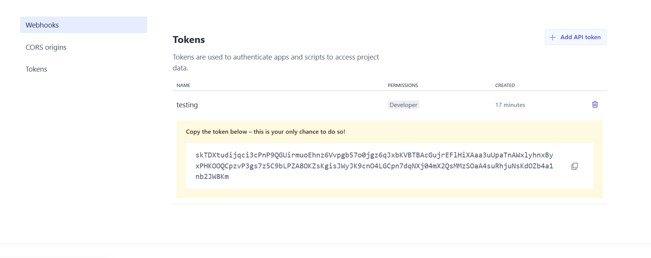

const sanityClient = require('@sanity/client');

const client = sanityClient({

projectId: 'your-project-id', // Replace with your actual project ID

dataset: 'production', // Replace with your dataset name

apiVersion: '2025-01-13', // Use a valid API version

token: 'your-token', // Replace with a valid token

useCdn: false // Disable CDN for authenticated requests

});

Replace ProjectId value with my **projectId.**Add Token Value Into this part of code.  
Run node importData.js in terminal of VScode  
